DATA STRUCTURES AND ALGORITHMS LAB - 1 ASSIGNMENT

Student Details
- Name: Pratyush Deo Singh
- Registration Number: 25BCE5101
- Course / Branch: B. Tech CSE (CORE)
- Semester: 2nd
- Subject: Data Structures and Algorithms
- Faculty Name: Dr. Malini A

Program 1(a): Linear Search in 1D Array
Aim
To write a C program to search an element in an array using Linear Search.
Algorithm
- Read number of elements
- Read array elements
- Read the element to be searched
- Compare the element with each array element
- Display the position if found
Program Code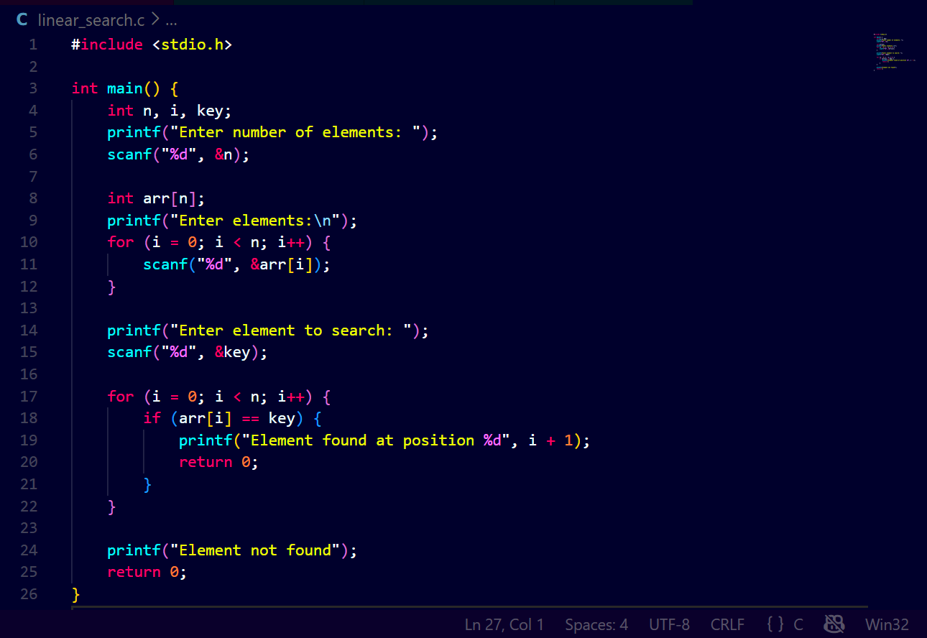
Output
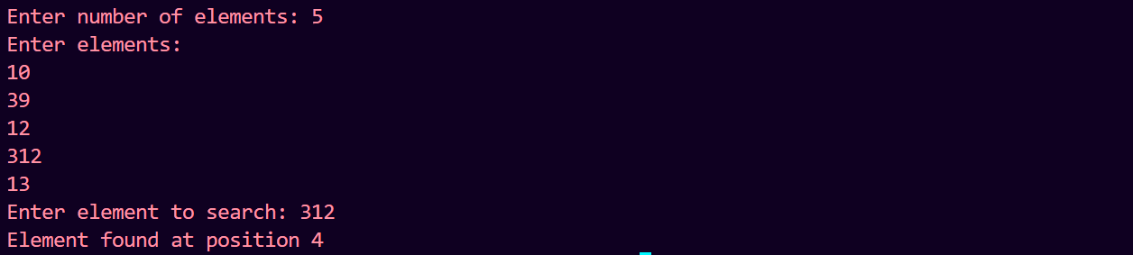
Program 1(b): Binary Search in 1D Array
Aim
To write a C program to search an element in an array using Binary Search.
Algorithm
- Read number of elements
- Read sorted array elements
- Read the element to be searched
- Apply binary search logic
- Display the position if found
Program Code
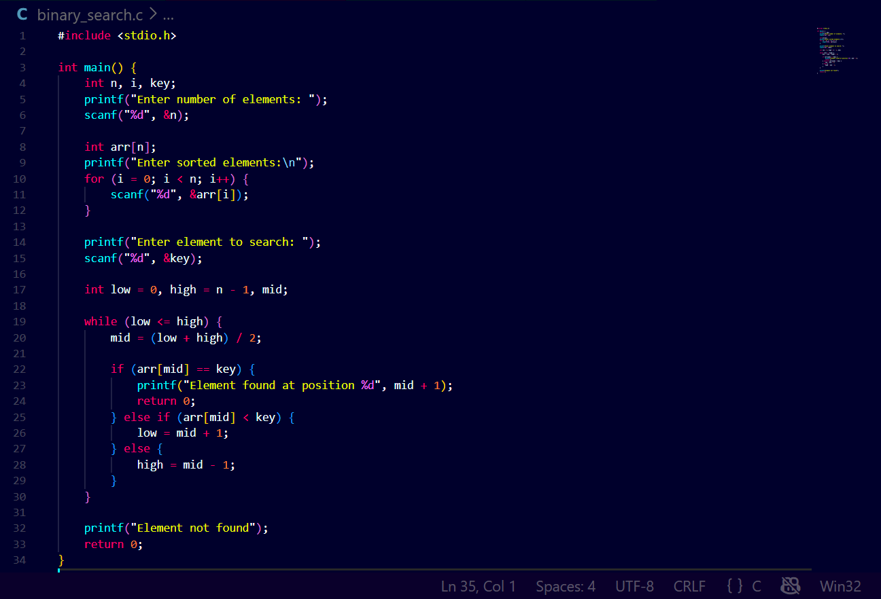Output
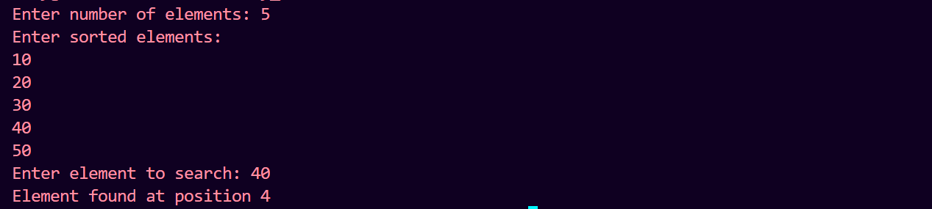

Program 2(a): Selection Sort
Aim
To write a C program to sort numbers in ascending order using Selection Sort.
Algorithm
- Read number of elements
- Compare each element with remaining elements
- Place smallest element at correct position
- Repeat until sorted
Program Code
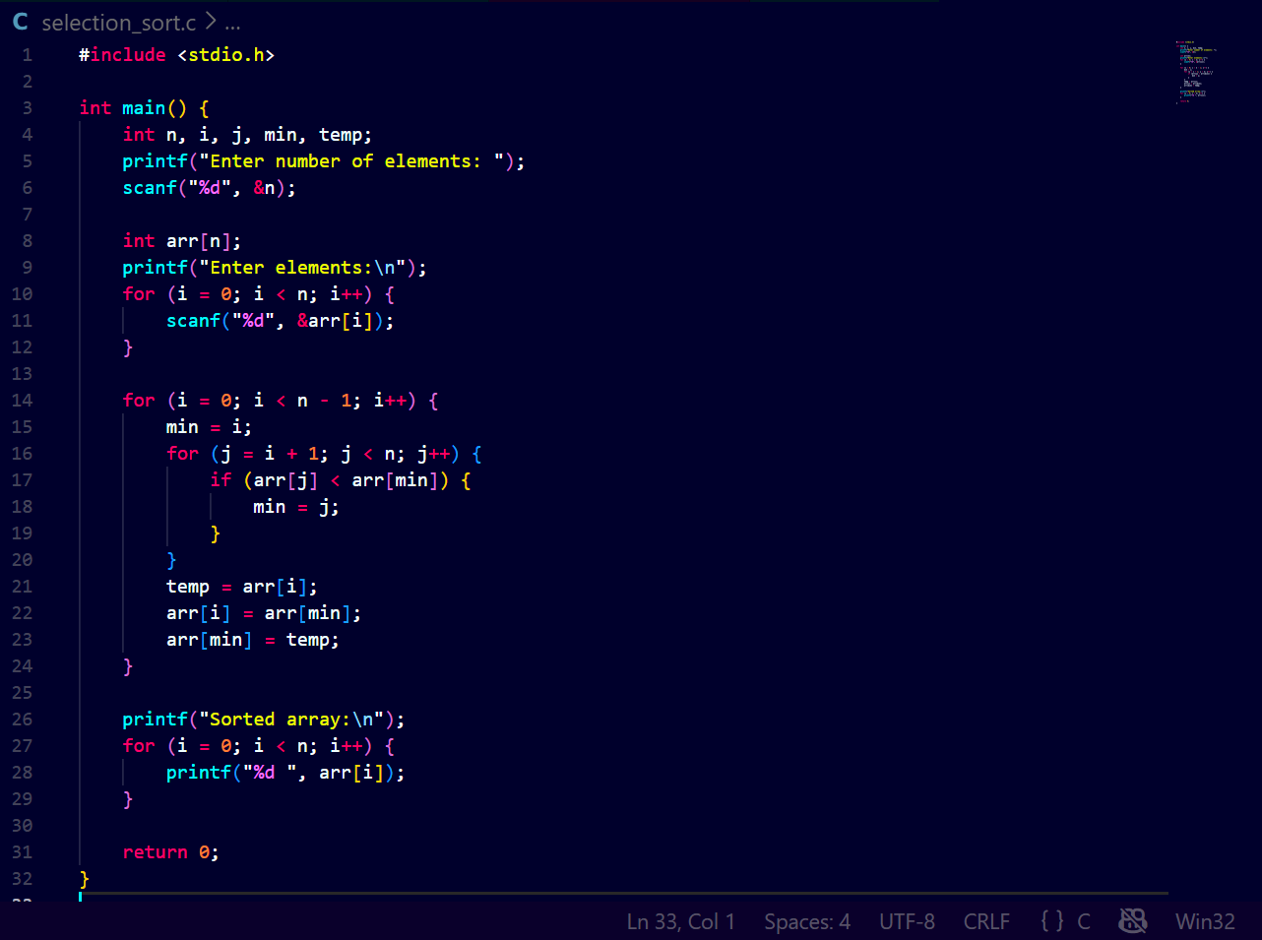Output
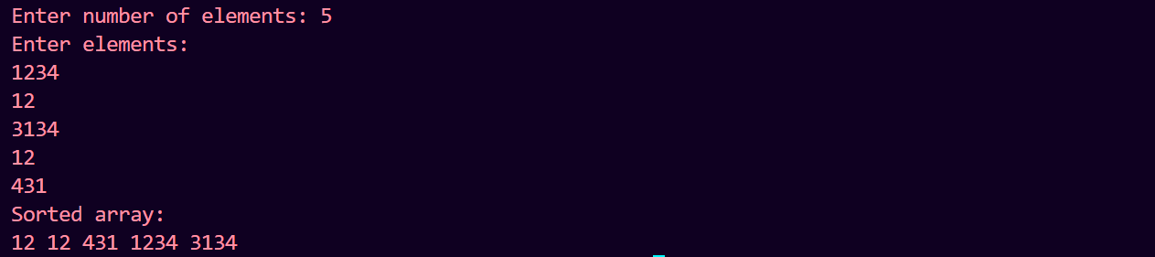
Program 2(b): Insertion Sort
Aim
To write a C program to sort numbers in ascending order using Insertion Sort.
Algorithm
- Read number of elements
- Insert each element into its correct position
- Repeat until array is sorted
Program Code
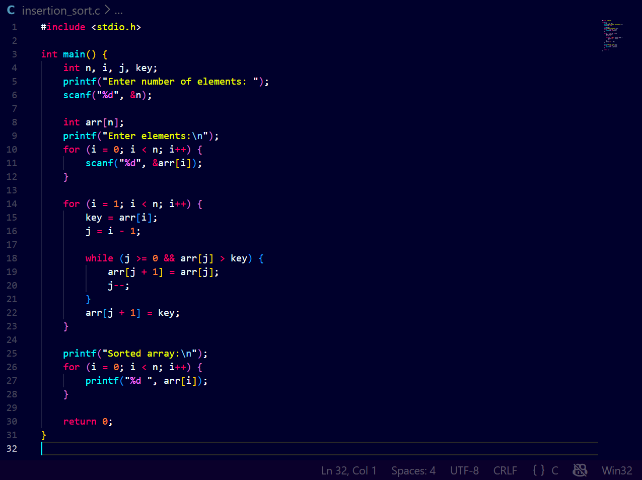Output
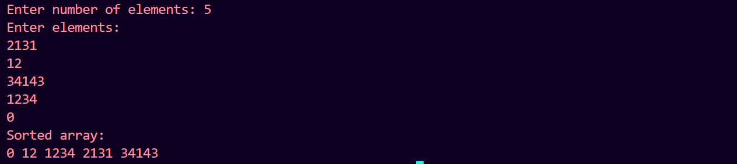

Program 3: Sum of Elements in 2D Array
Aim
To write a C program to find the sum of elements in a 2D array.
Algorithm
- Read number of rows and columns
- Read array elements
- Add all elements
- Display the sum
Program Code
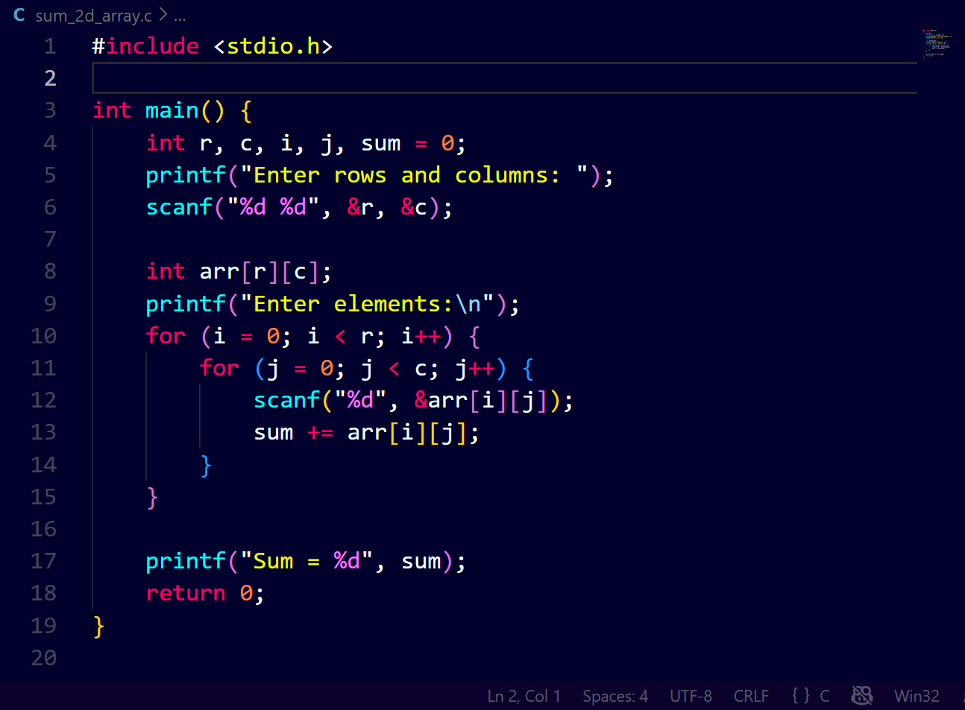Output
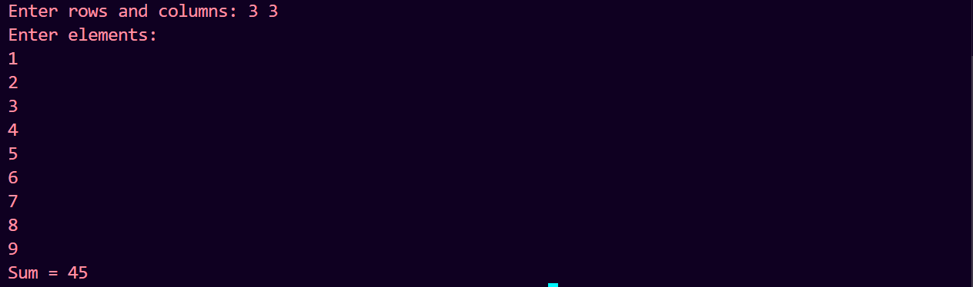

Program 4: Search an Element in 2D Array
Aim
To write a C program to search an element in a 2D array and display its position.
Algorithm
- Read rows and columns
- Read array elements
- Read the element to search
- Compare element with each array element
- Display position if found
Program Code
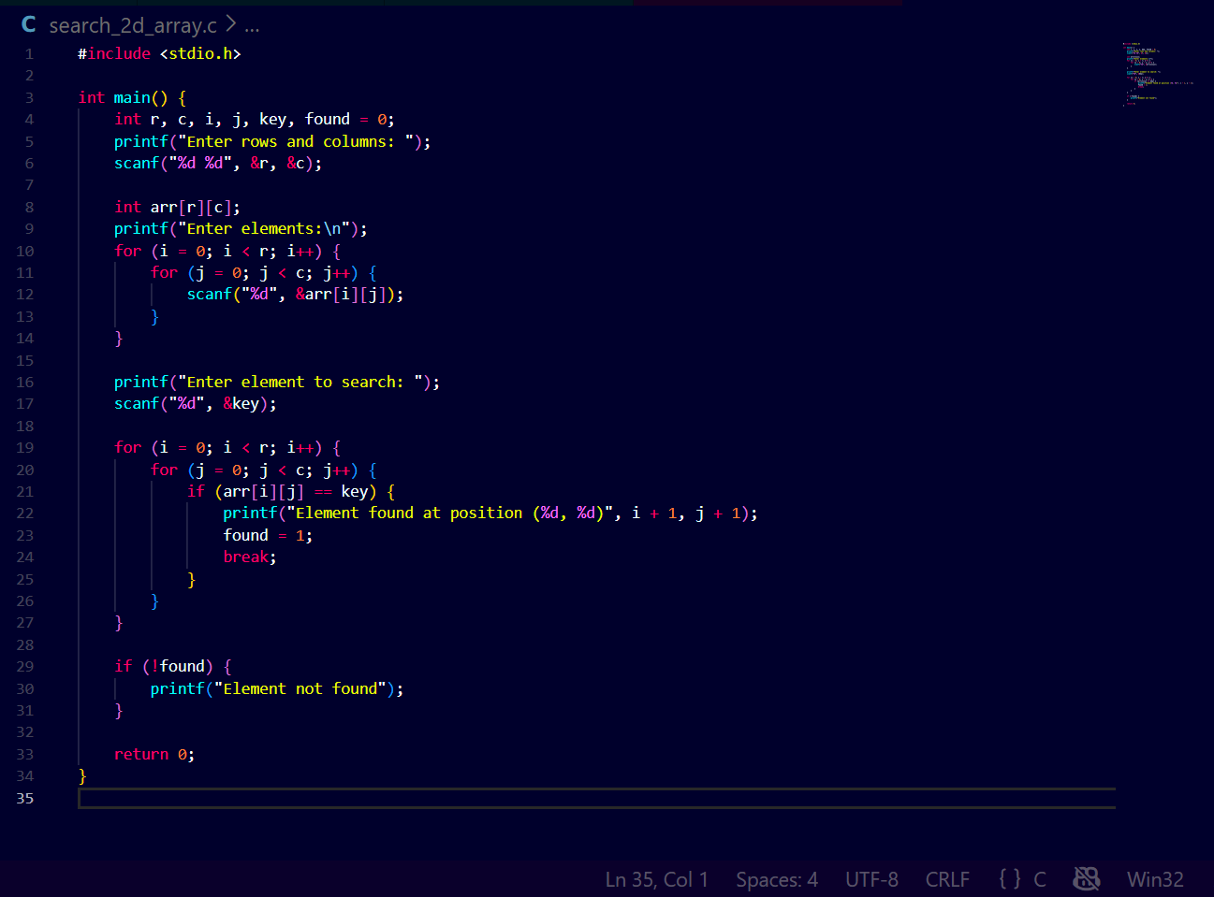Output
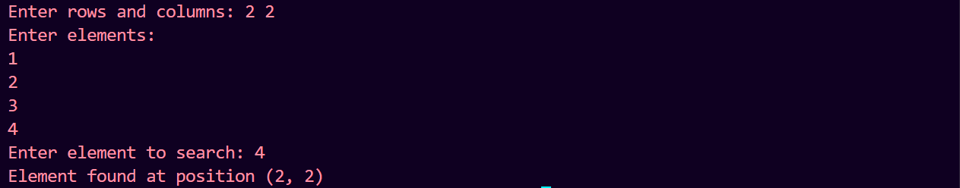
Result
Thus, all the given programs were successfully executed and the outputs were verified.

